Lab 6 Snort
Report:
1. Installing Snort on SEED VM using the following commands. When prompting for the interface to listen on, type esp0s3.
sudo apt-get update
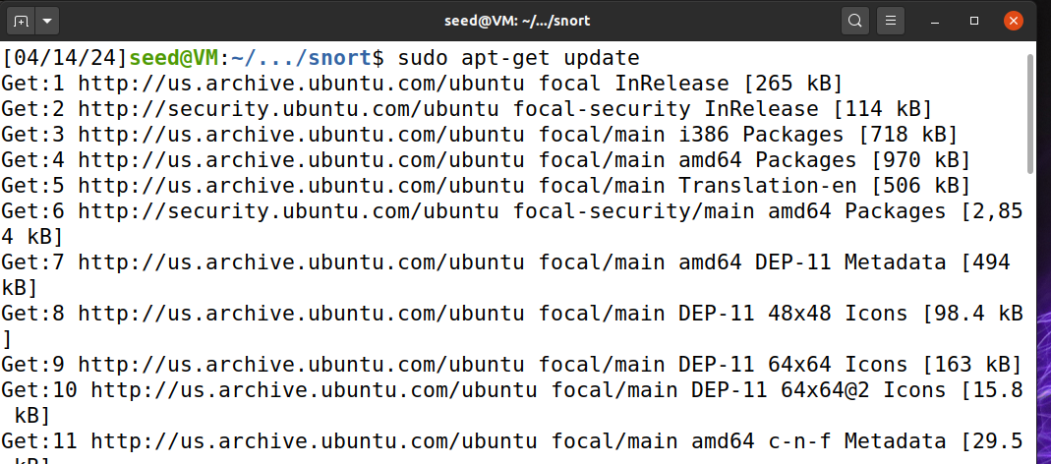
sudo apt-get upgrade
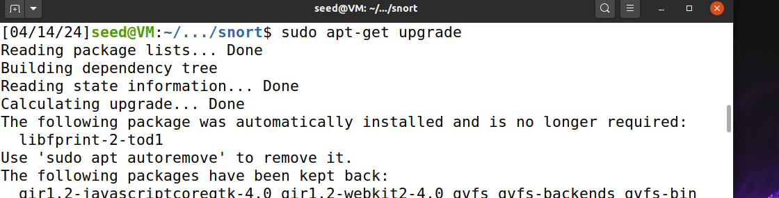
sudo apt install snort
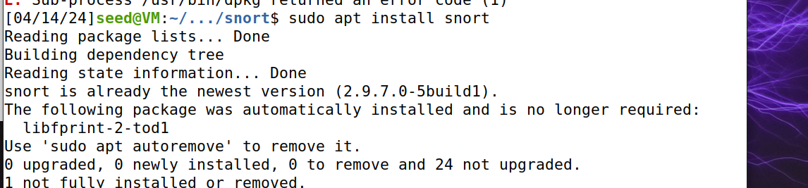
sudo snort
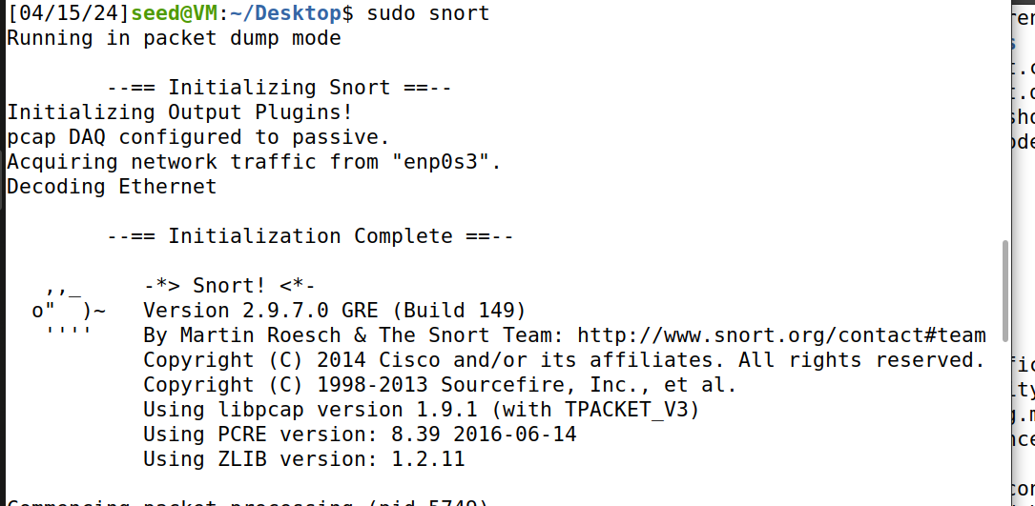
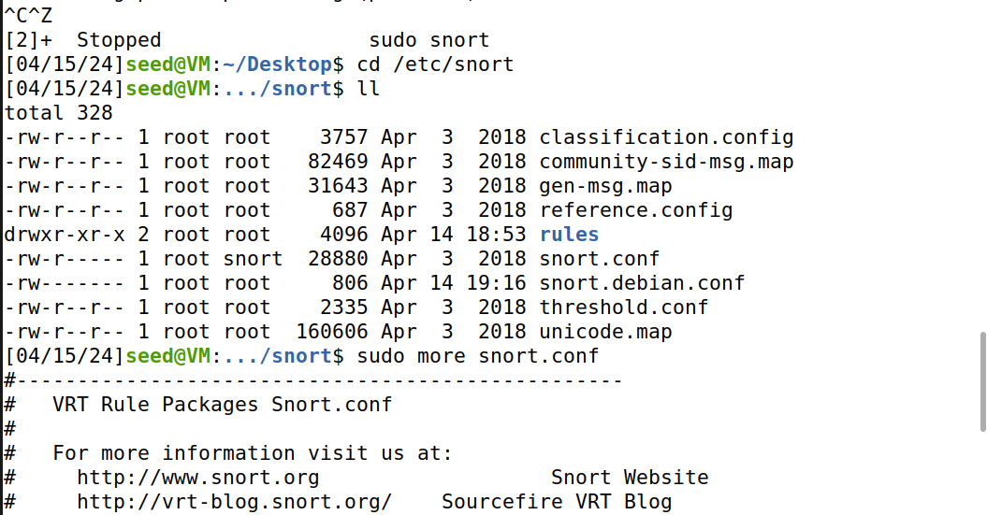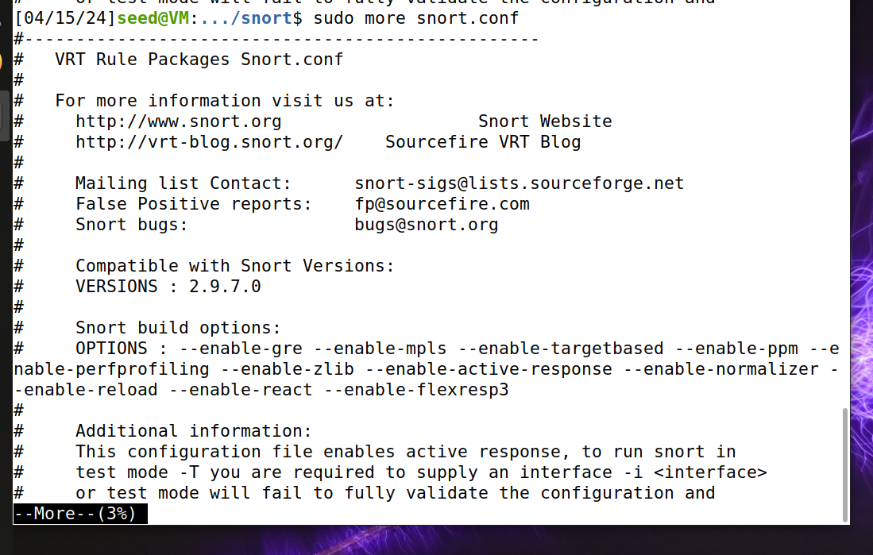

Again,

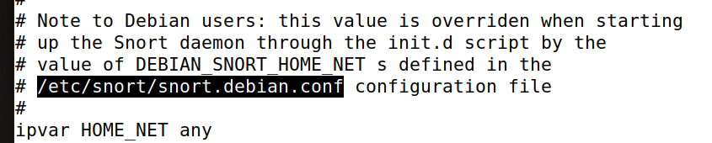
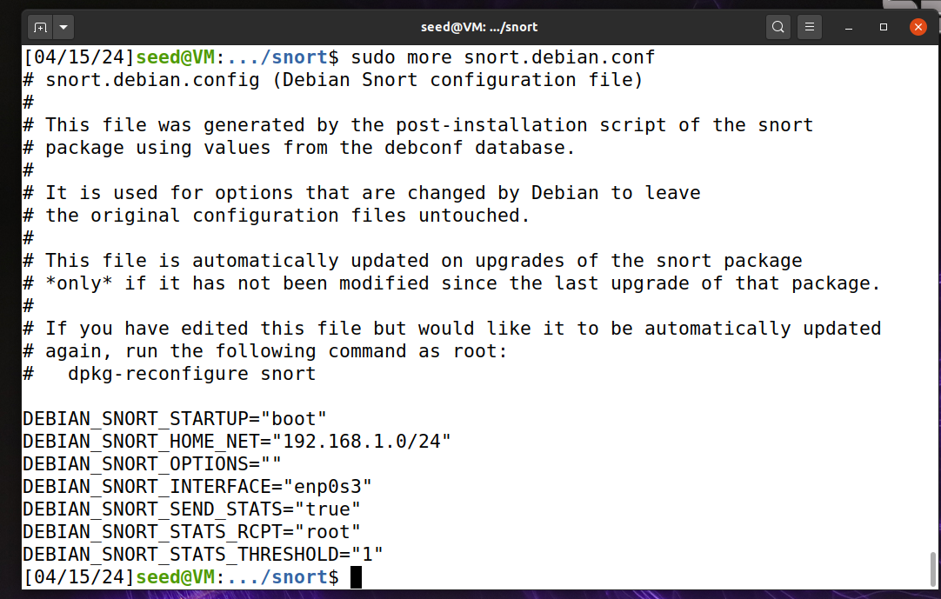
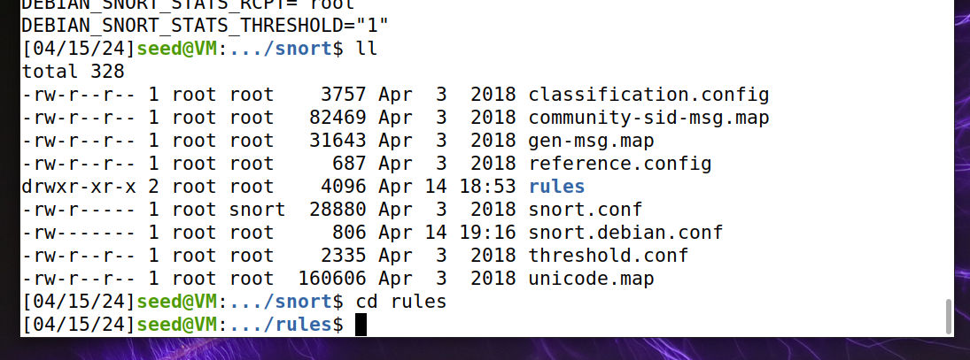

Looking at the ‘.rules’, seeing ddos, scan etc there.
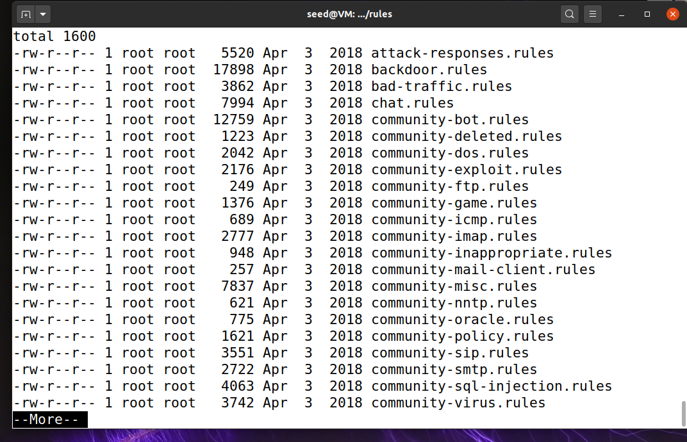

More ddos.rules

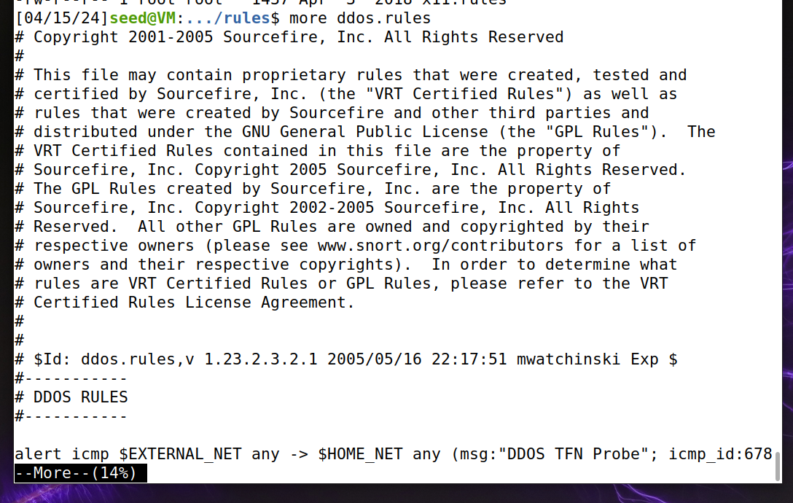

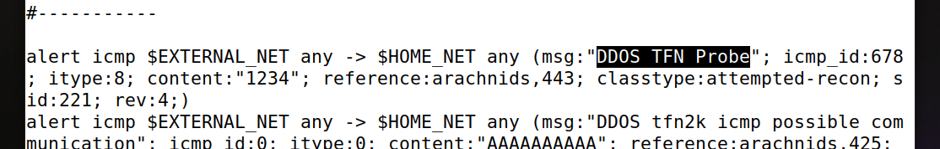

2. We run snort command
sudo snort -q -A console -i enp0s3 -c /etc/snort/snort.conf
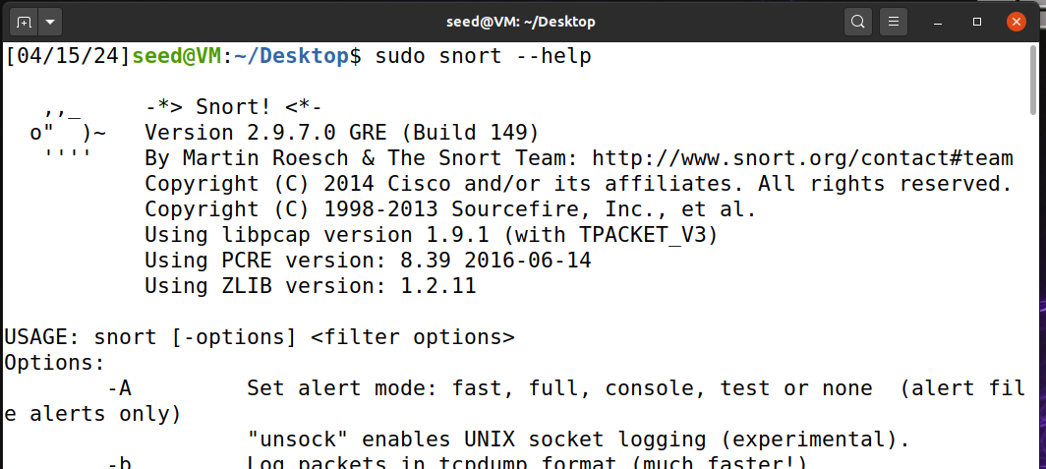

Then the sudo snort -q -A console -i enp0s3 -c /etc/snort/snort.conf

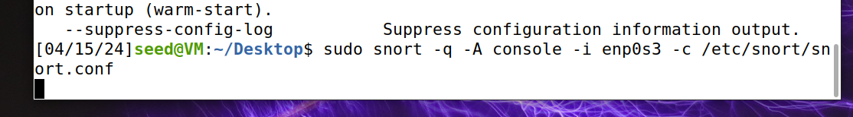
3. Generating ping traffic. Providing screen captures for traffic generation and snort.
Initiating the ping 8.8.8.8
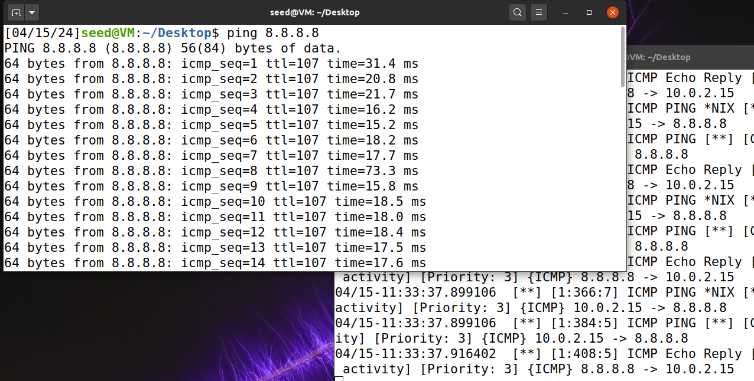
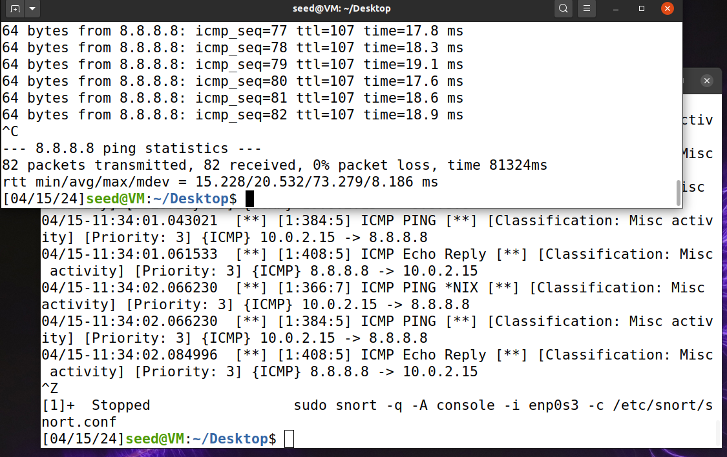
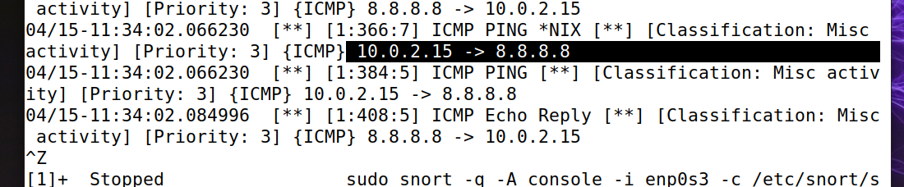

Creating python program,

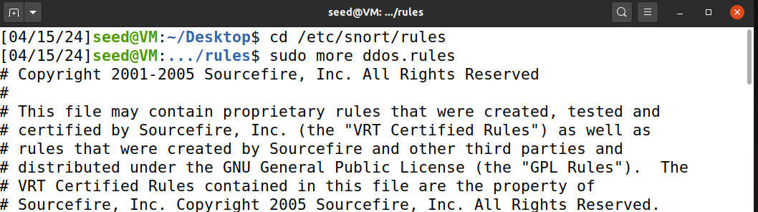


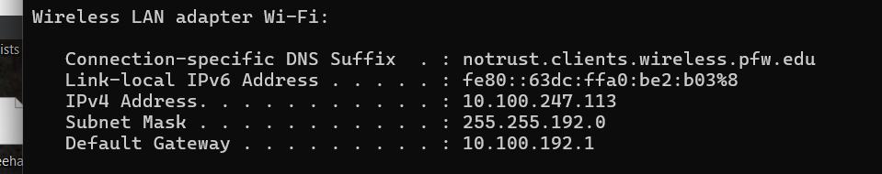

Creating python program to generate a DDoS attack and run it.

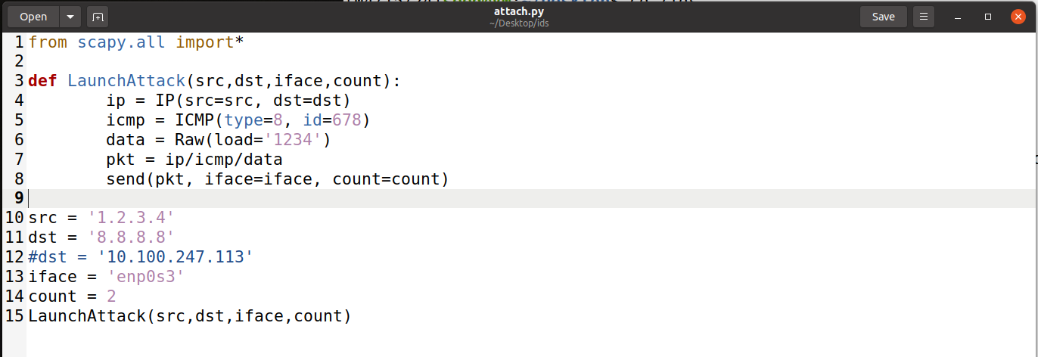

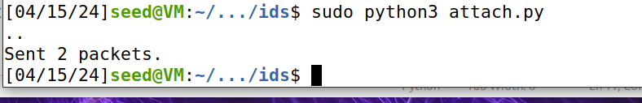
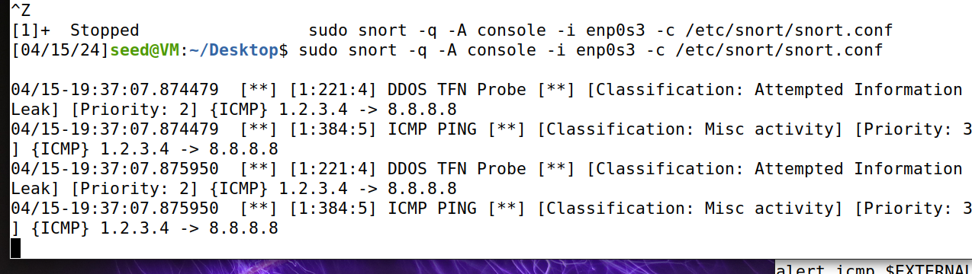

4. (i) Create python program to generate a DDoS attack (tfn) and run it.

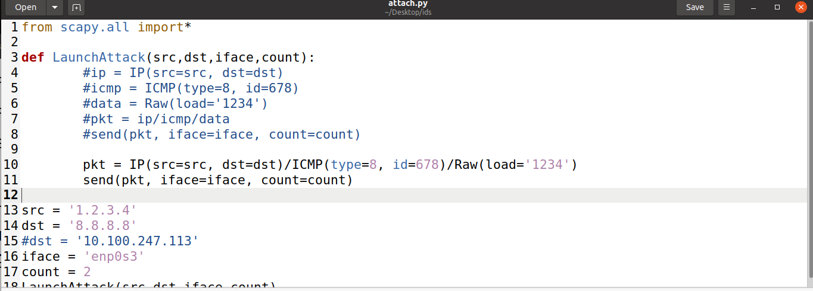
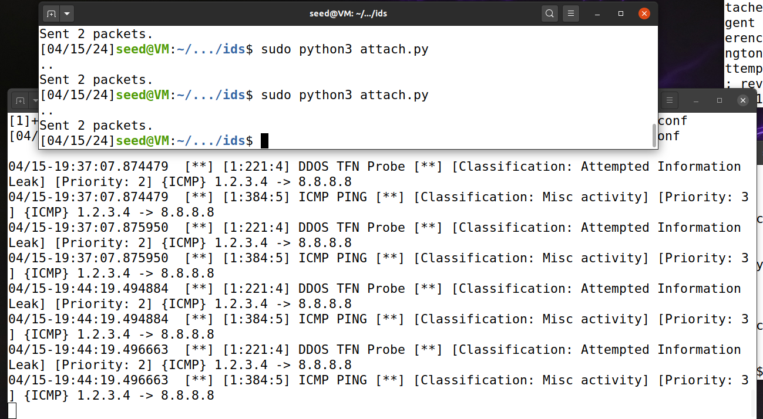

4. (ii) Create python program to generate a DDoS attack (tfn2k) and run it.

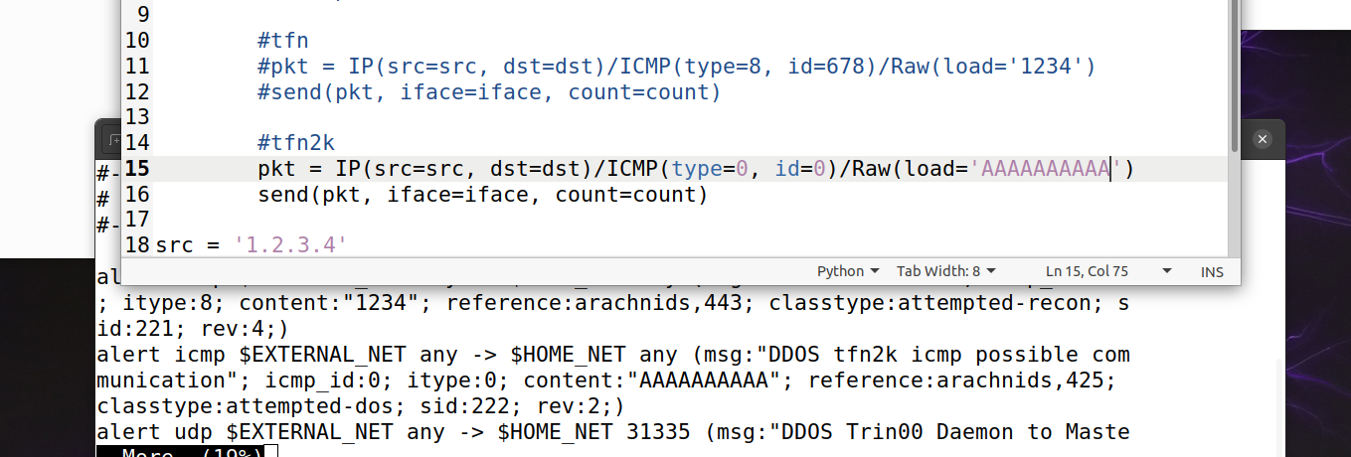
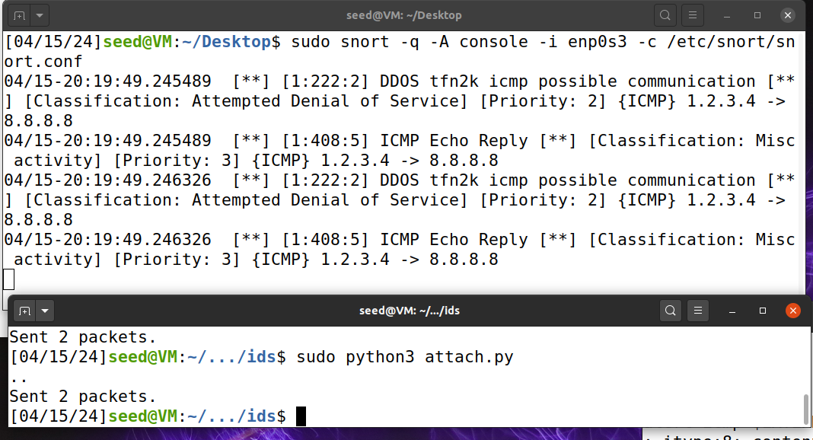
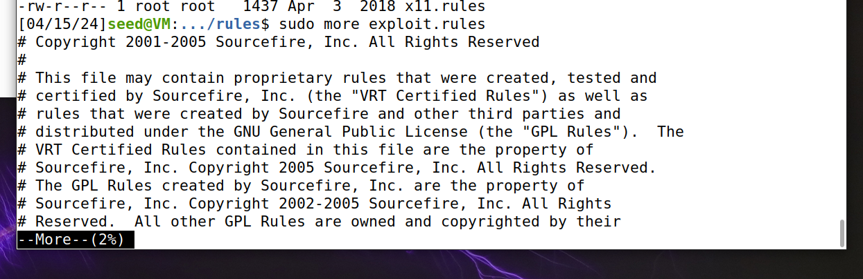

5. (i) Create python program to generate a code injection attack (ntalkd) and run it

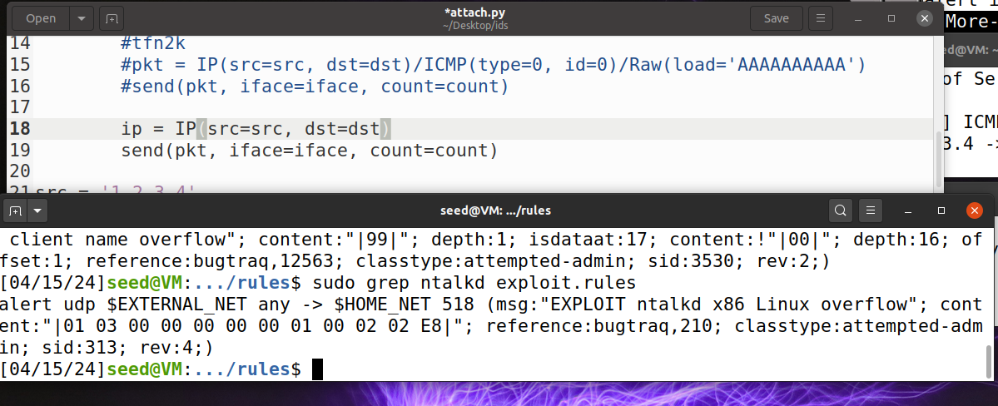
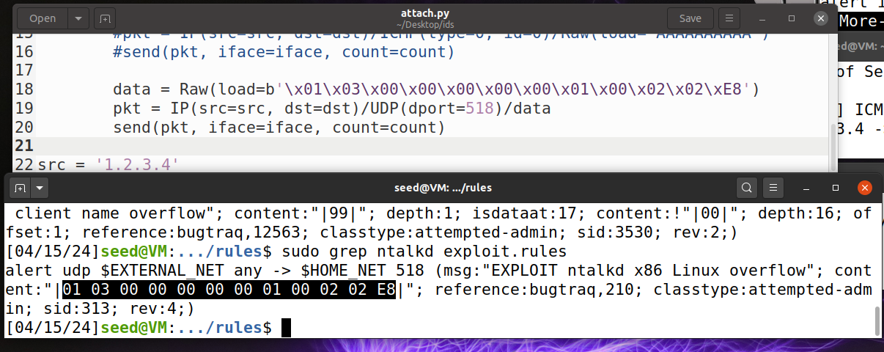

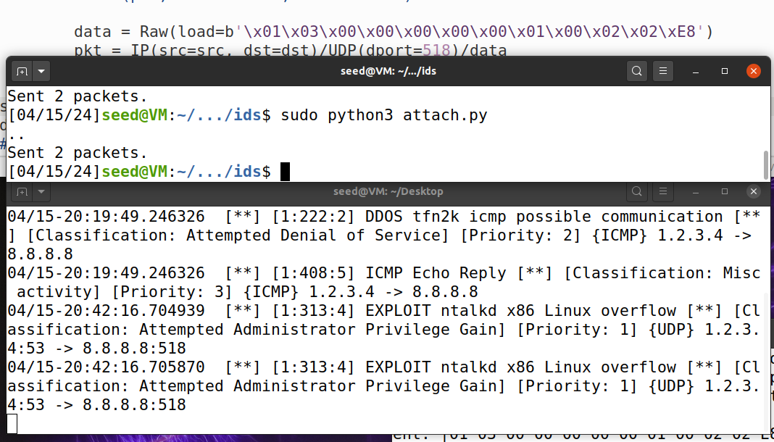

5. (ii) Create python program to generate a code injection attack (mountd) and run it

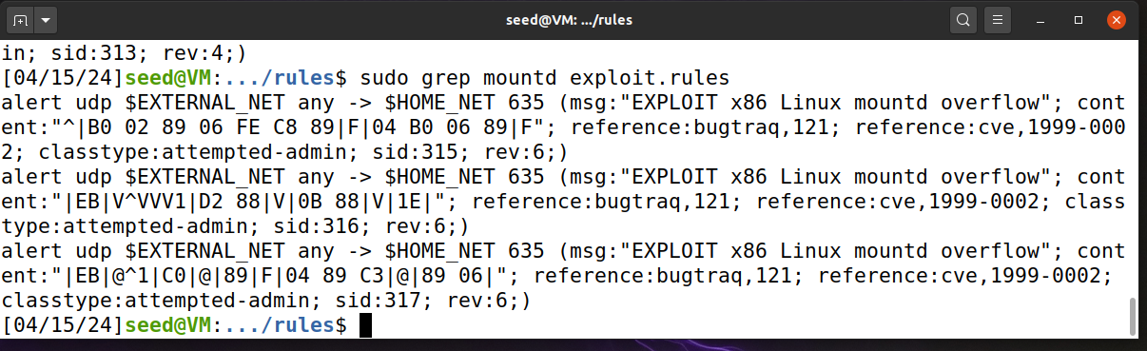
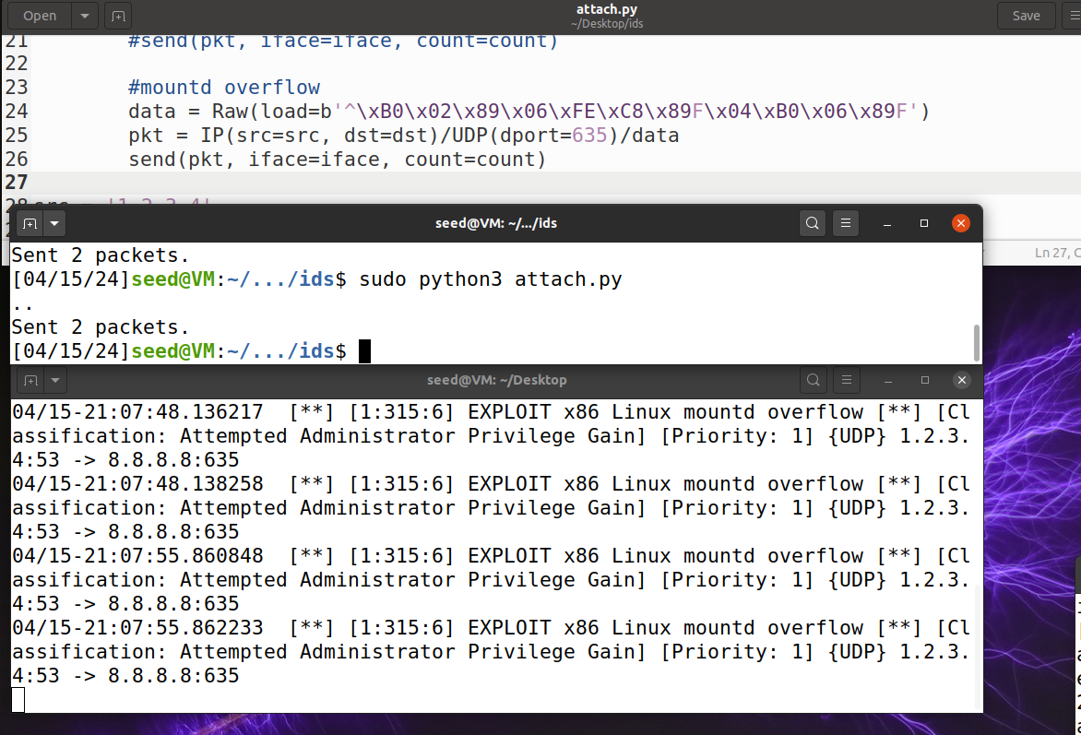
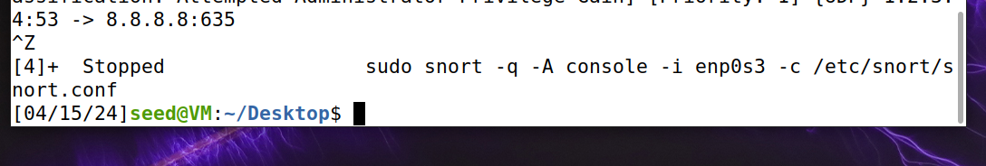
6. (i) Create python program to generate a scanning attack (nmap XMAS) and run it
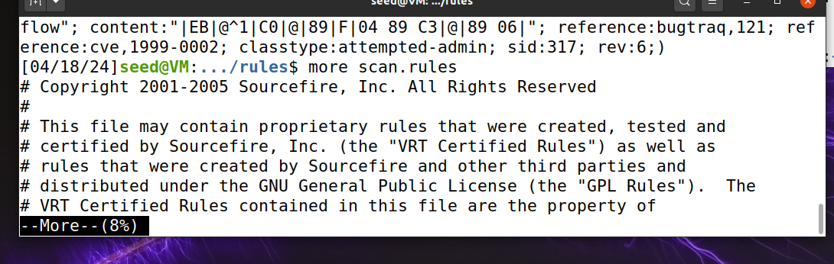
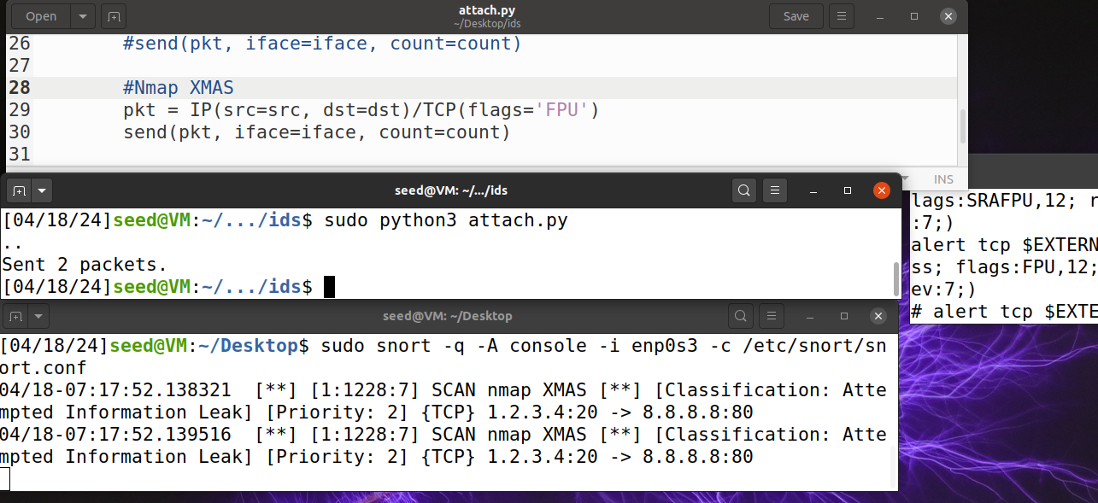

6. (ii) Create python program to generate a scanning attack (Solarwinds IP scan) and run it
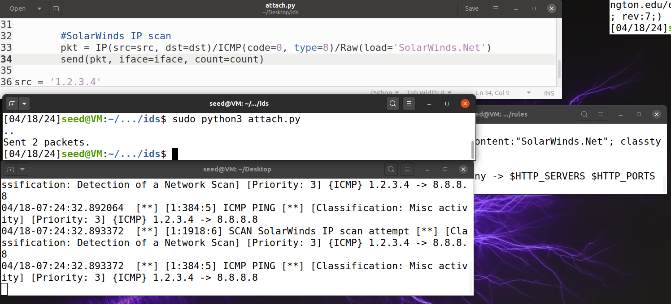

7. Write your own code to generate the following 2 attacks
a. SCAN SYN FIN
b. SCAN cybercop UDP bomb

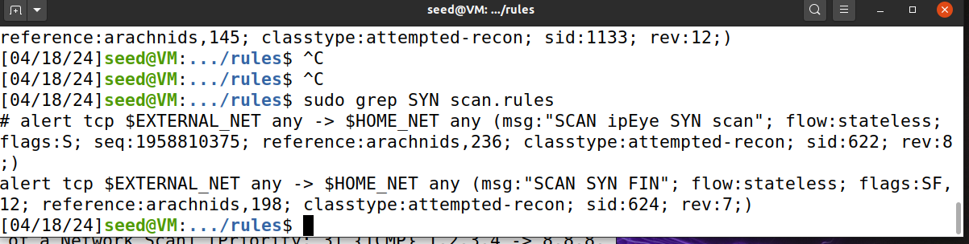

7. a. SCAN SYN FIN
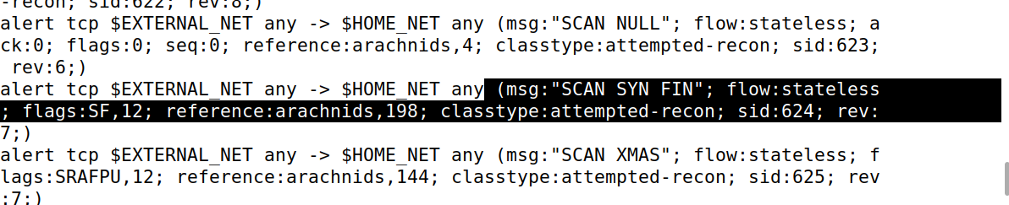

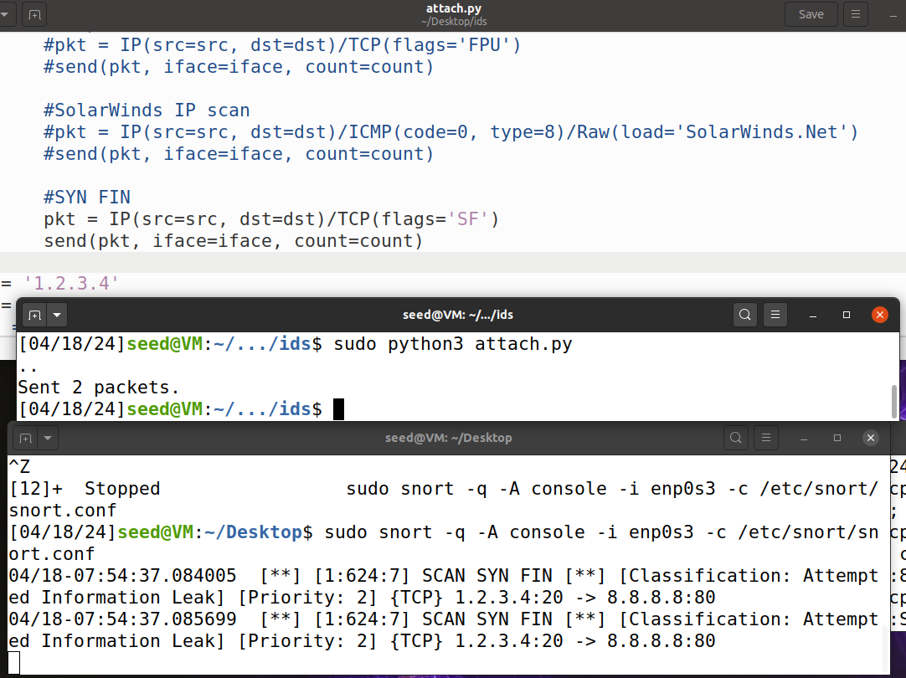

7. b. SCAN cybercop UDP bomb



